**MALAVIYA NATIONAL INSTITUTE OF TECHNOLOGY ,Jaipur**



**PROJECT REPORT ON**

**ONLINE TRANING AND PLACEMENT MANAGEMENT SYSTEM**

**SUBMITTED TO: SUBMITTED BY:**

**DR. NAMITA MITTAL ASHISH GOYAL**

**(2016UCP1100)**

**ABHISHEK TIBREWAL**

**(2016UCP1103)**

**CONTENT:**

* **Preface**
* **Acknowledgement**
* **Introduction**
* **Objective**
* **Planning and Requirement analysis**
  + **Drawbacks in existing systems**
  + **User Requirements(features)**
  + **Data gathering**
* **Design**
  + **Use-Case Diagram**
  + **E-R Diagram**
  + **Relational Schemas**
  + **Normalization of relational schemas**
* **Implementation**
  + **Coding**
  + **Glimpse of our site**
  + **Tools and technologies used**
* **References**

**PREFACE**

The “Online Training and Placement Management System” is an online application that can be accessed throughout the organization and outside as well with proper login provided. It offers many flexible and convenient features, allowing admin, students and company to maximize time and efficiency. It has been developed to override the problems prevailing in the practicing manual system.

The application is reduced as much as possible to avoid errors while entering the data. It also provides error messages while entering invalid data. No formal knowledge is needed for the user to use this system. Thus by this all it proves it is user-friendly.

This system allows to update the information for students and companies. Also the admin manages both students and companies in the way such that the admin can access and update their information.

**ACKNOWLEDGEMENT**

We take this opportunity to express our sincere gratitude to all those who helped us in various capacities in undertaking this project and devising the report.

We are privileged to express sense of gratitude to our

respected teacher Dr. Namita Mittal for providing a vision

about the system. We have been greatly benefited from

their regular critical reviews and inspiration throughout

my work.

We would also like to thank our friends and companions

for their cooperation and compliance.

With sincere regards,

Ashish Goyal

Abhishek Tibrewal

**INTRODUCTION**

The “Online Training and Placement Management System” can lead to error free, secure, reliable and fast management system. It can assist the user to concentrate on their other activities as well as on the record keeping. Thus it will help organization in better utilization of resources. The organization can maintain computerized records without redundant entries. That means that one need not be distracted by information that is not relevant, while being able to reach the information.

The aim is to automate its existing manual system by the help of computerized equipments and full-fledged computer software, fulfilling their requirements, so that their valuable data/information can be stored for a longer period with easy accessing and manipulation of the same. Basically the project describes how to manage for good performance and better services for the clients.

This system can be used as a web application for the Training and Placement Officers of the college to manage the student information with regard to placement and training. Students and companies logging should be able to upload their information. Administrator logging in may also search any information put up by the students. This will also help in fast access procedures in placement related activities.

**OBJECTIVE**

This project is aimed at developing a web application for the Training and Placement Department of the College that can be accessed throughout the organization with proper login provided. This system can be used as a web application for the Training and Placement Officers (TPO) of the college to manage the student information with regard to placement.

The main objective of the project on “Online Training and Placement Management System” is to manage the details of students, company, training, placement, registration. It manages all the information about training, placement, students and companies. The project is totally built at administrative end and thus only admin can access all the information. However students and companies can also access and update their information.

The purpose of the project is to build an application program to reduce the manual work for placement and training cell of college, for students and for companies. It maintains records instead of written materials.

**Planning and Requirement analysis**

* **Drawbacks in existing systems**
* Some problems with existing systems :
* Student has no profile of its own to see.
* Student can’t update his/her information by himself/herself, he/she has to go to Placement & Training Cell office and the updation is done manually.
* No confirmation mail sent to student if he/she got selected by any company.
* There is no separate notification panel. All the information comes through mail, so anyone can’t see all the information at one place.
* The maximum work of admin is manual.
* **User Requirements(Features)**
* For the students:
  + Student can register at training and placement cell.
  + Can login and view his/her profile.
  + Can update his/her information that were provided at the time of registration.
  + Student can view general notifications from T & P cell and can also see the details of companies that are visiting.
  + A student can apply for the visiting company for internship or placement if he/she is eligible for that.
* For the companies:
  + A company can register at training and placement cell.
  + Companies add basic details like, for which branch the company is coming and criteria for that branch.
* For the admin:
  + Can add new admin at training and placement cell.
  + Add general notifications for the students.
  + Have access to all the information about students and companies means admin can view or update information of students and company.
  + Only the admin gives approval to the company after verifying that it’s a correct company or not.
  + Admin also update the absents of students.
  + Admin changes the status of the students from not selected to got intern/placement after receiving final result from the company.
  + Admin can view the list of students who got placement or internship in which company.
* Student Notification Panel:
  + There will be general notifications about interviews, pre-placement talks etc.
  + List of visiting companies will be there with their details and basic criteria.
  + Student can also view the name of companies in which he/she registered.
* Admin Notification Panel:
  + List of all students who got placement.
  + List of all students who got internship.
  + List of all registered students for company (separate for internship and placement).
* The password of every user is stored in database in encrypted form, so that no one can understand it.
* If any user is logged in then no other user can log in at the same time on the same browser.
* **Data Gathering**

The data is gathered from various resources:

* Student’s data is collected from the students of our college (MNIT Jaipur).
* Student’s images are collected from students through MNIT-ERP and social media.
* Company’s information is gathered from the mail received from “Placement & Training Cell, MNIT Jaipur” during our campus placement and training drive.

**Design**

* + 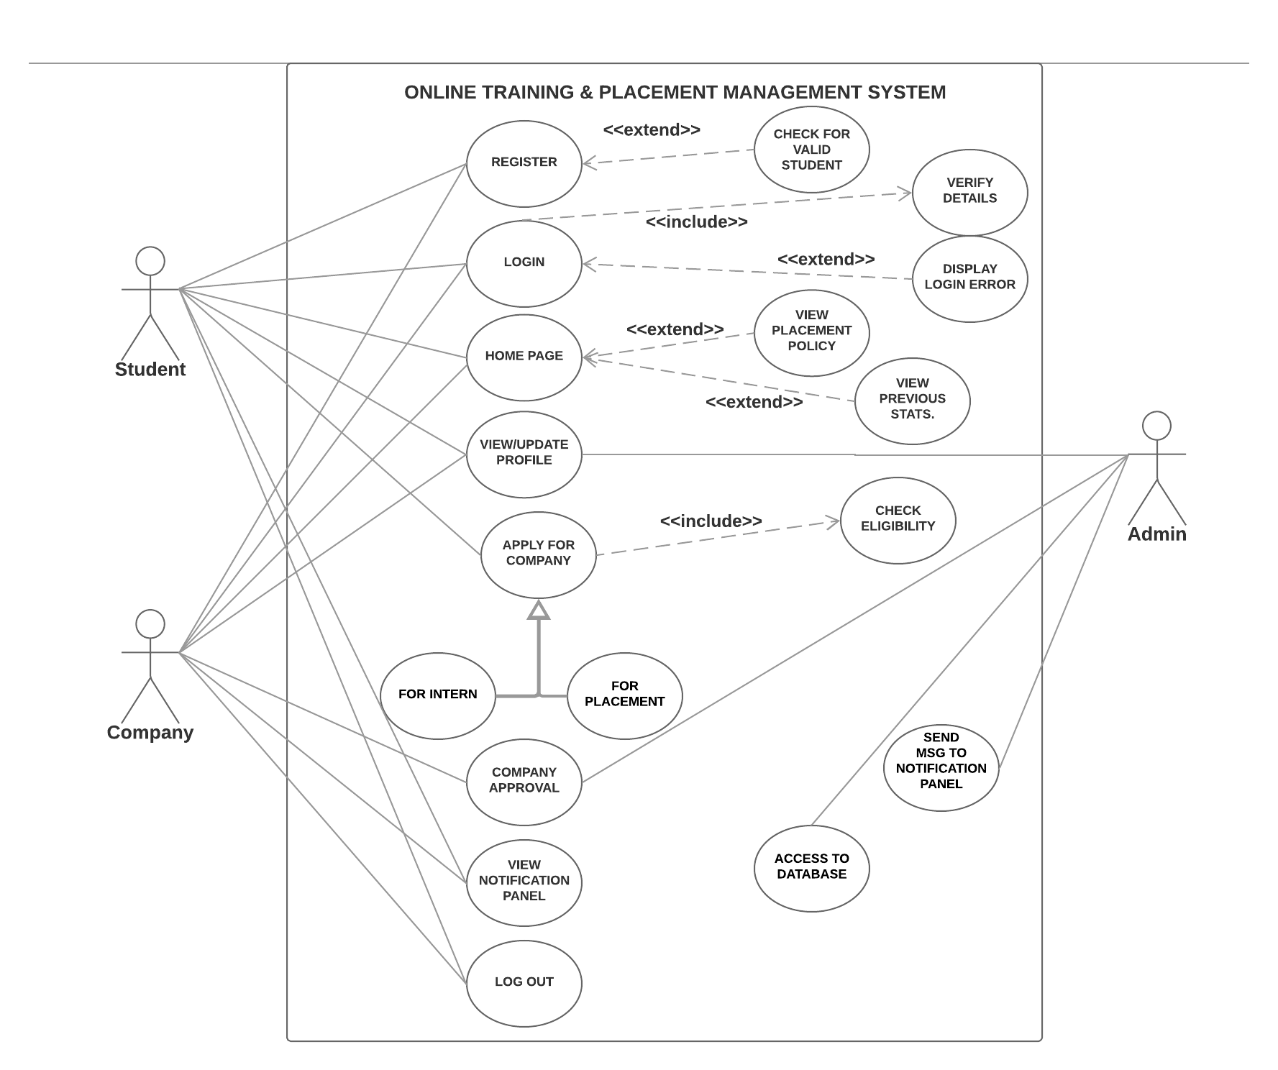**Use-Case Diagram**
  + **E-R Diagram**

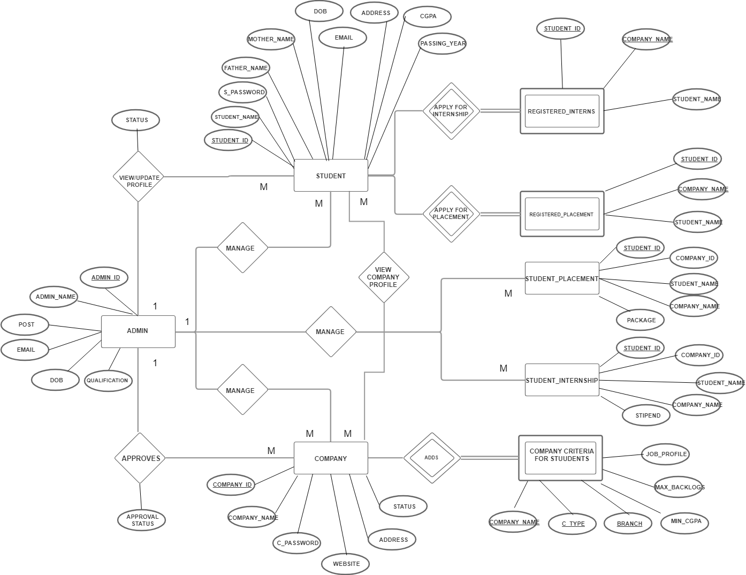

* + **Relational Schemas**
  + **Normalization of relational schemas**

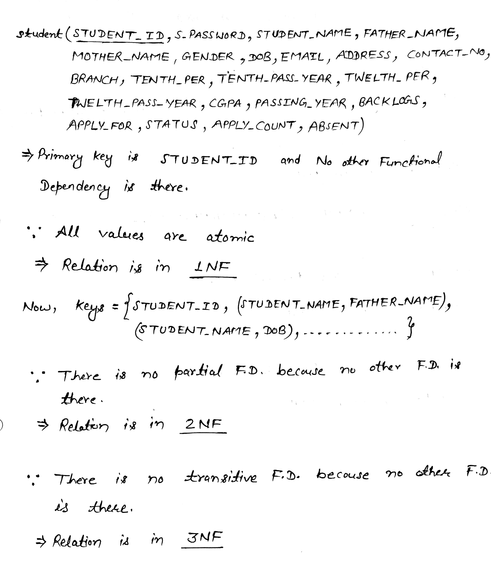

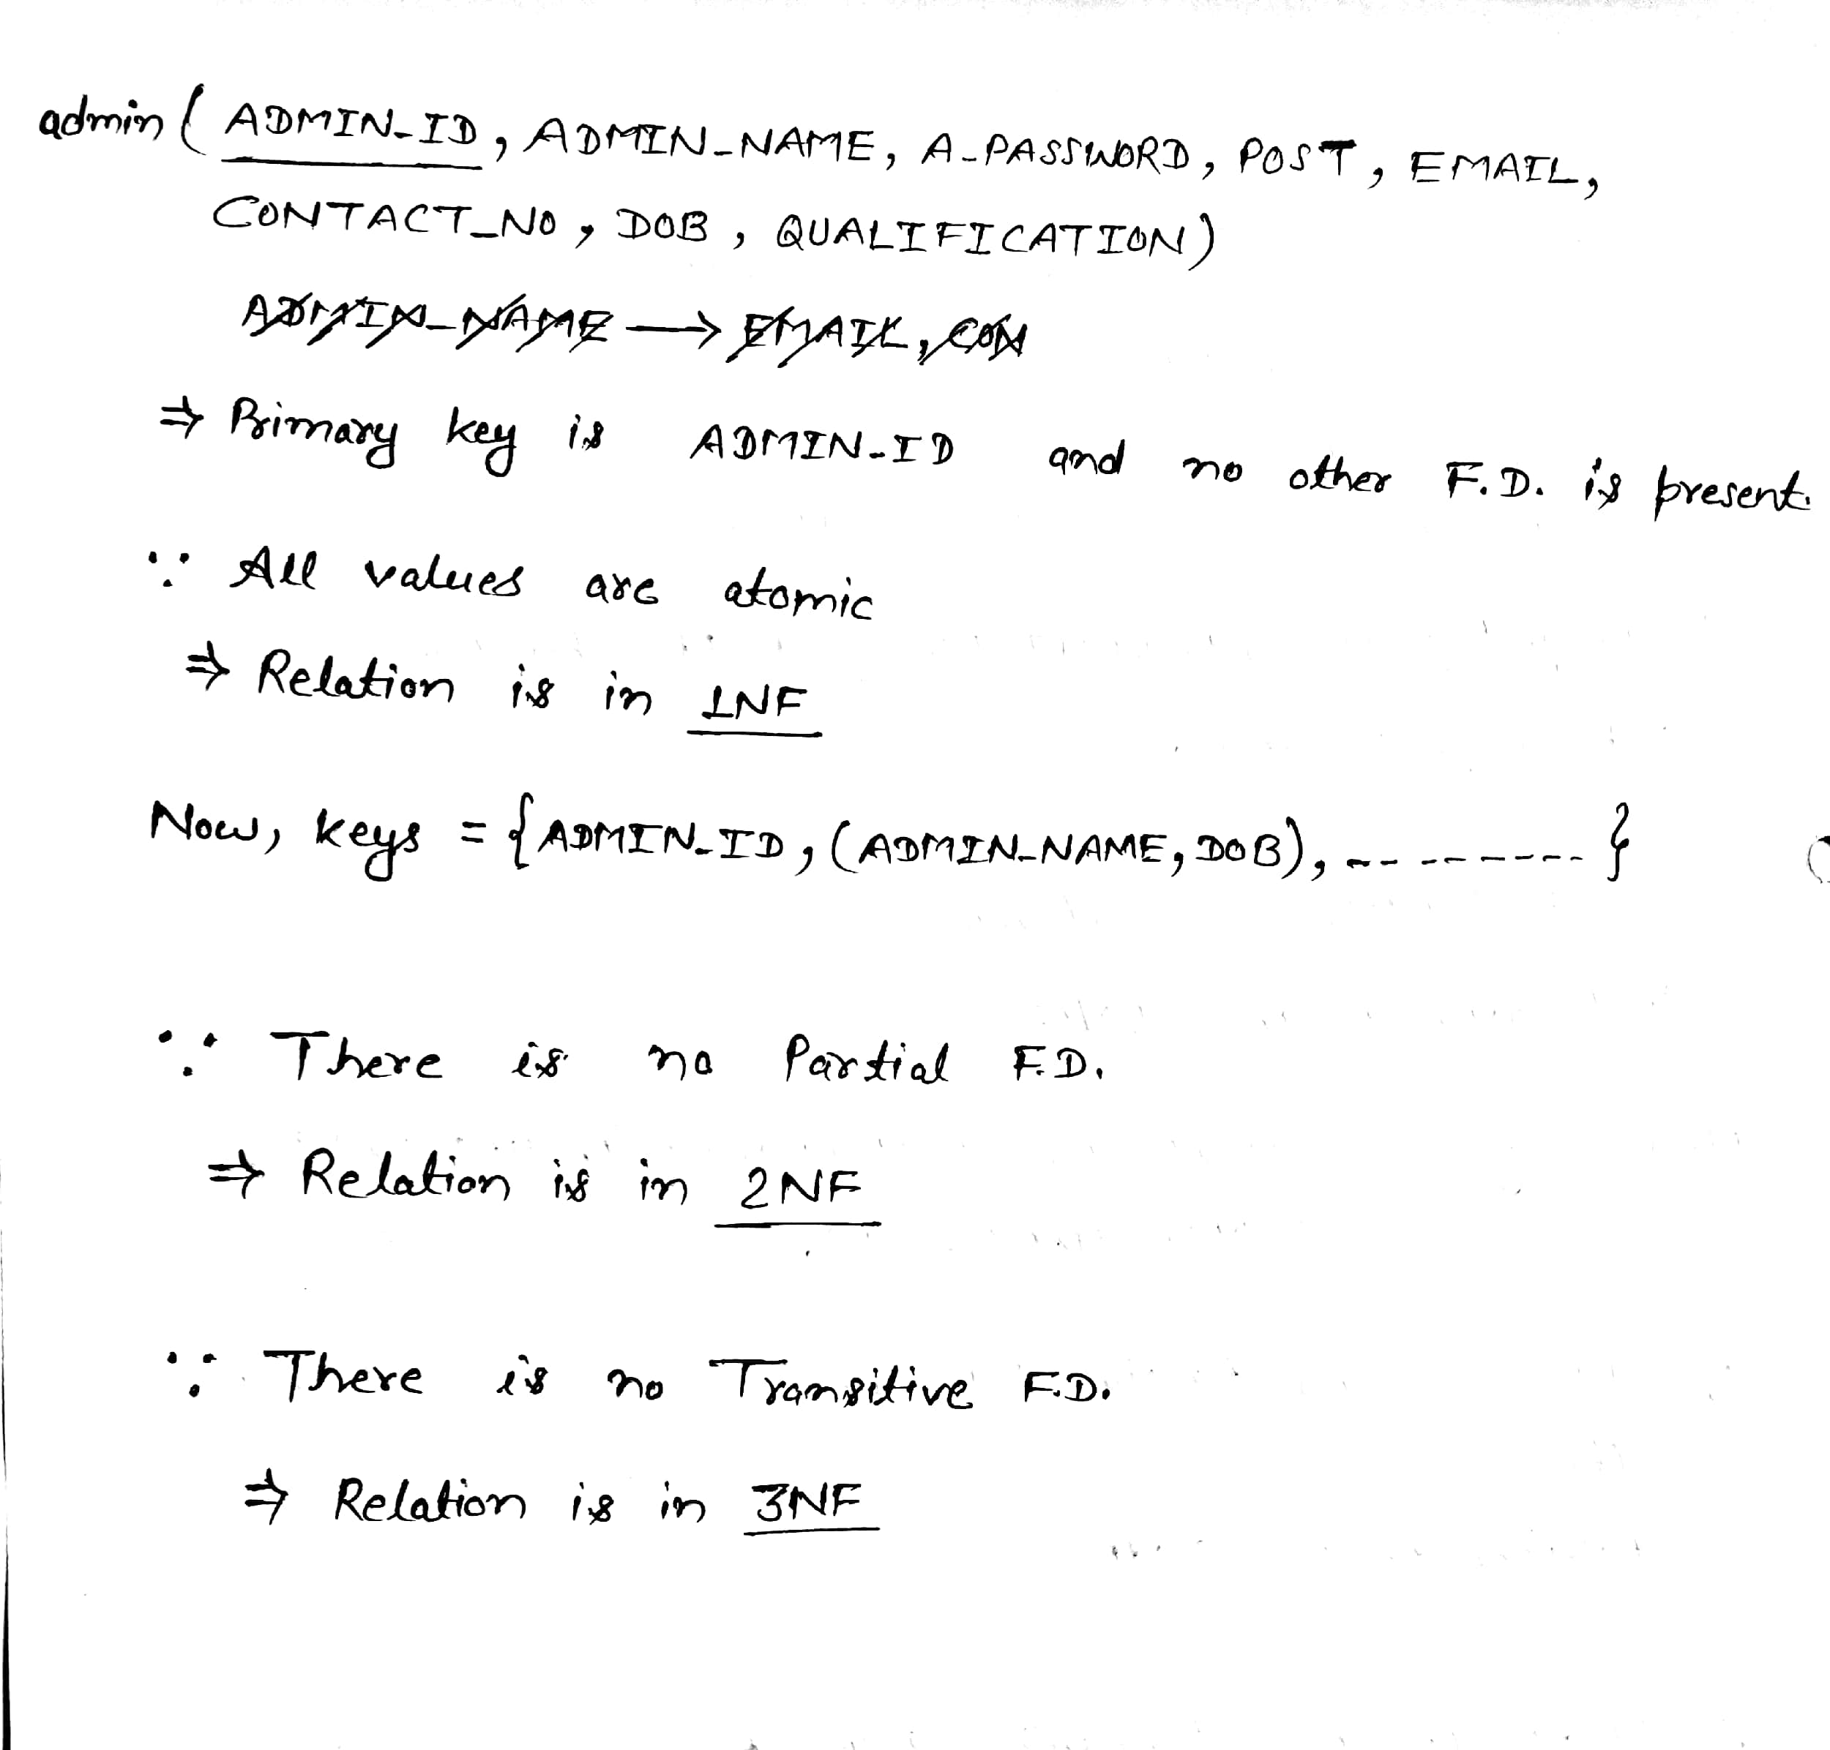

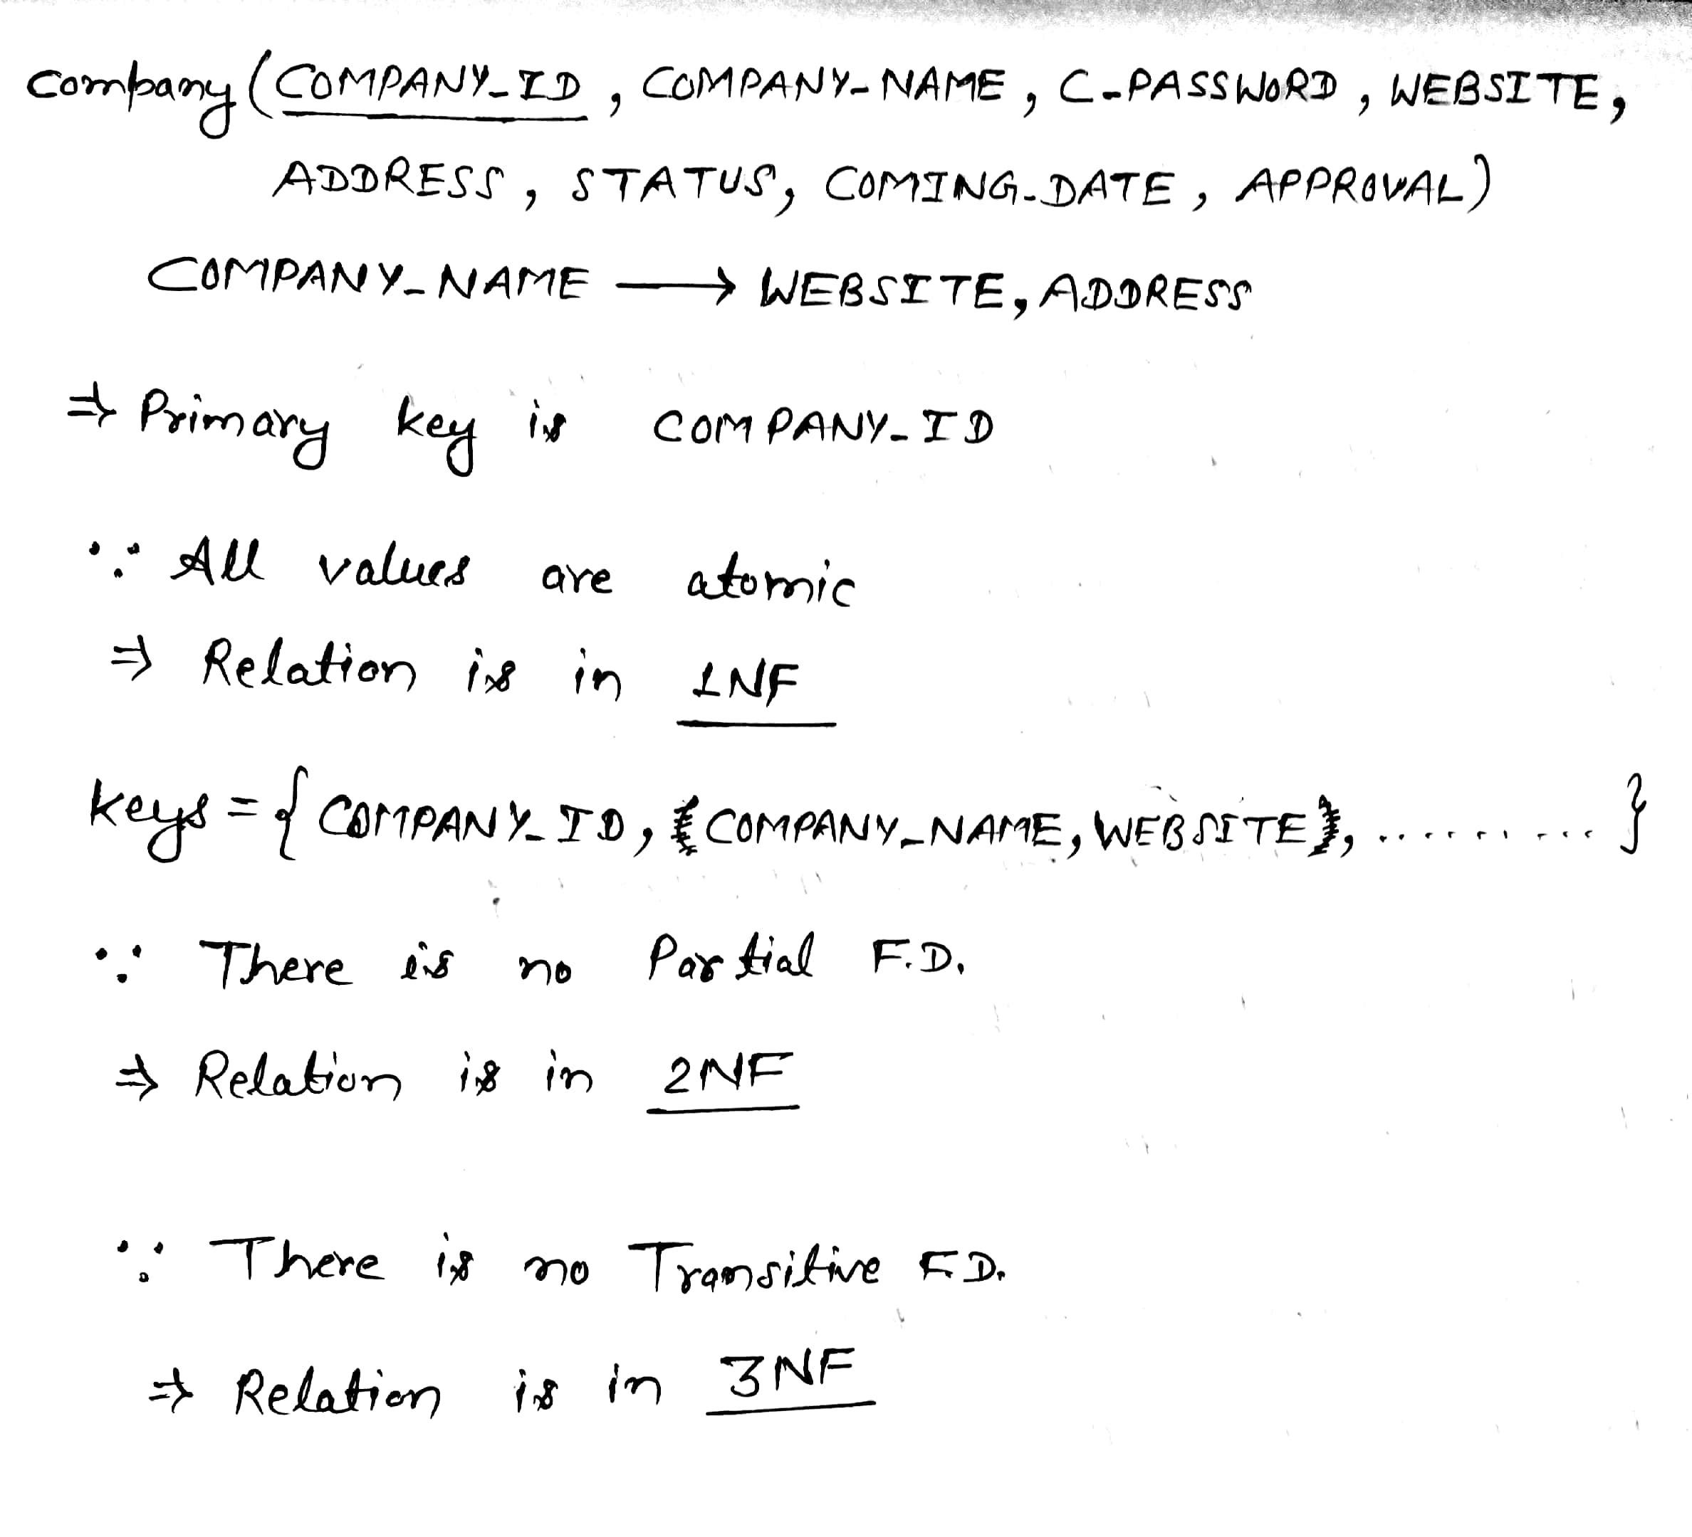

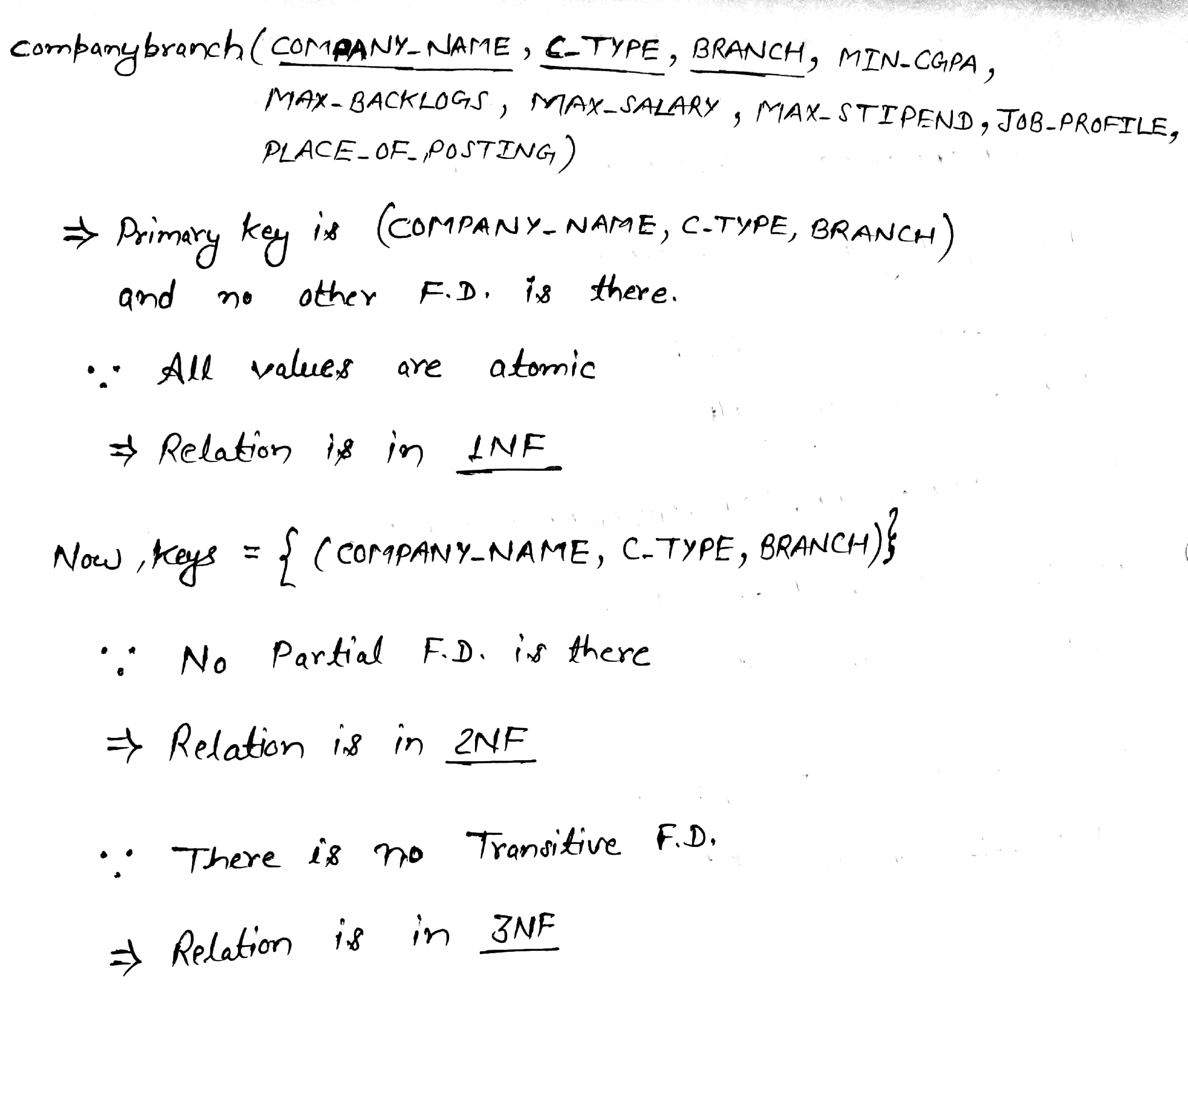

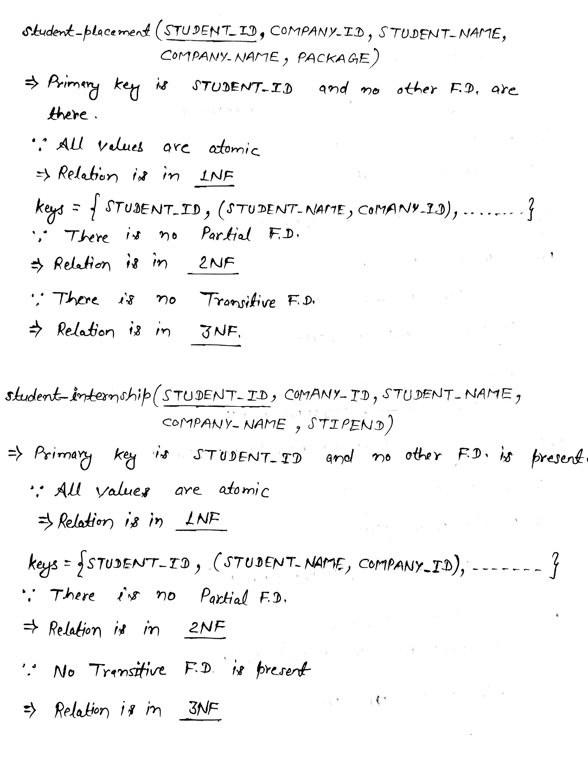

**Implementation**

* + **Coding**

Session-protection

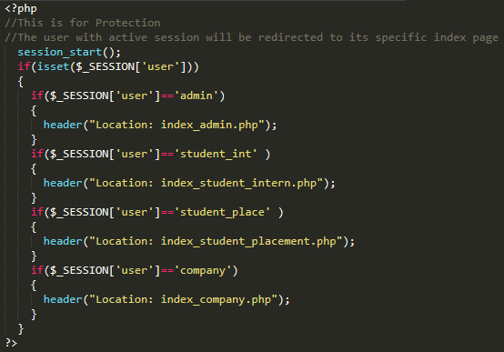

Companies with same branch that the students have are shown during apply for the company section.

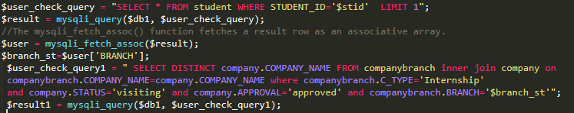

Various Constraints check, password encryption And  
 Displaying error and Success message

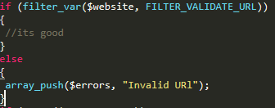

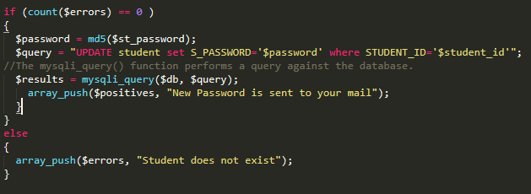

View registered company by student.

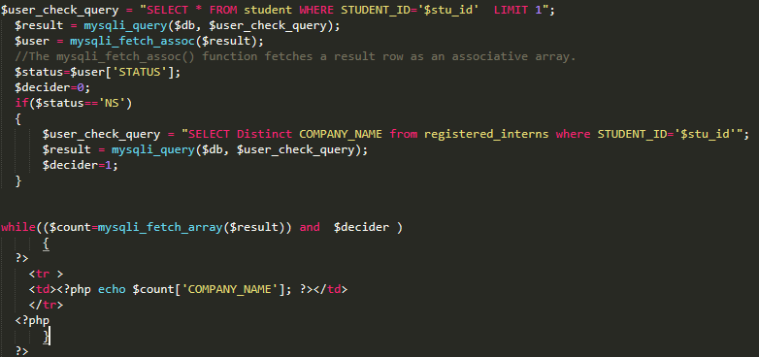

Insert, delete, update Queries

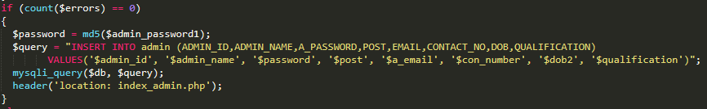

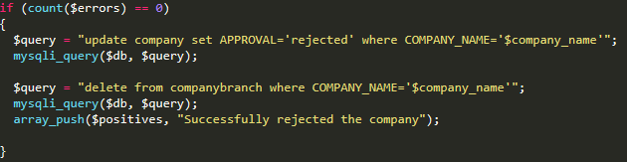

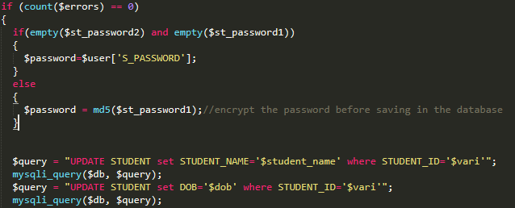

* + **Glimpse of our site**

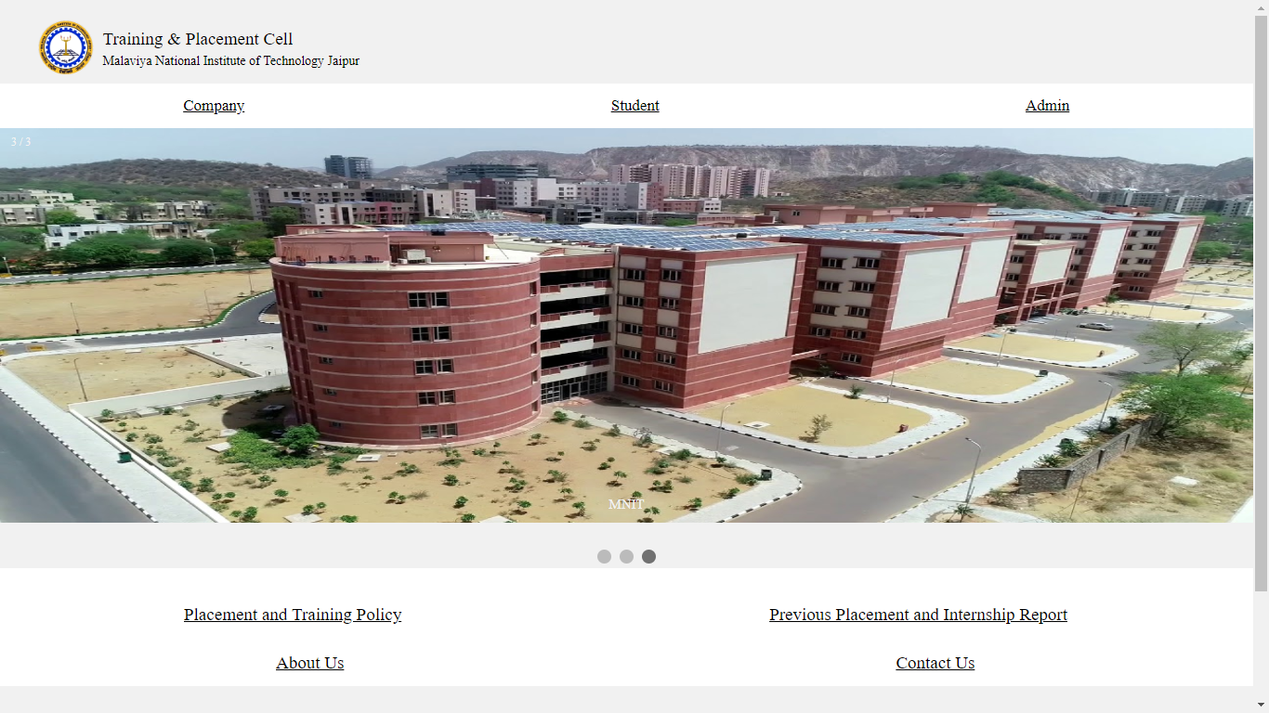

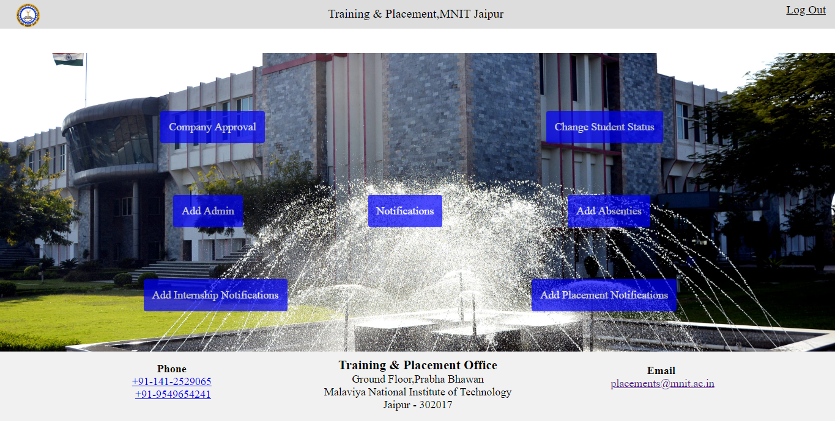

* + **Tools and technologies used**
* Back-End: php with mysql ( xampp server)
* Front-End: html, css , javascript
* Hardware Specification:
* Operating System- windows
* Browser that supports html, css, javascript.

**References**

* **Websites:** 
  + http://www.w3schools.com
  + https://www.quora.com
  + http://stackoverflow.com
  + https://www.tutorialspoint.com
* **Books**:
  + Database management system concepts by korth.